These are general supplies that students entering second grade will need during the year. Your child’s teacher may request specific items for projects that will be done with the class.
We will not have shared supplies this year, please label your child’s supplies.

- Mask
- Fiskars brand scissors
- 2 Boxes of crayons
- Colored pencils
- #2 pencils
- Bar/chunk eraser
- 6 Glue sticks
- 3 Packages of white copy paper
- Plastic, Two-pocket, 3-clip folders (1 Blue, 1 Green, 1 Red, 1 Yellow)
- Plastic pencil supply box (please label with your child’s name)
- 2 Spiral notebooks (Blue, Red)
- Composition notebook (black and white)
- Dry erase markers-Fine Tip
- Gallon ziplock bags (boys)
- Tissues
- 1-highlighter
- Sandwich ziplock bags (girls)
- 2 Clorox wipes
- Hand sanitizer
- Headphones (earbuds or over ear headphones)
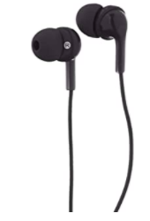example of ear buds. 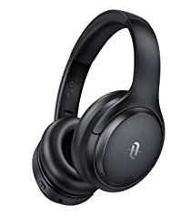 example of over ear headphones
Wish List for class:
- Extra Glue sticks
- White copy paper
- Gallon Ziploc bags
- Sandwich size Ziploc bags
- Paper towels
- Index cards
** Please know that if you are unable to bring any item, we will do what we can to supplement for your child. We do not want this to be a financial hardship.

