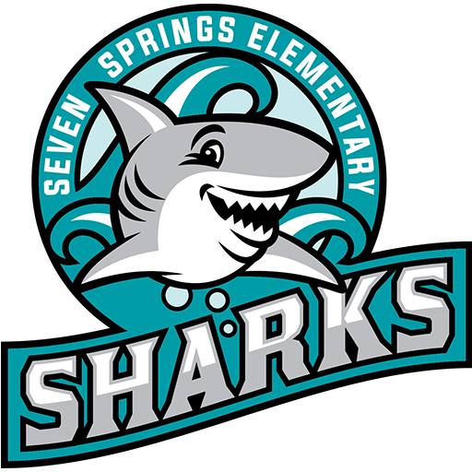

Seven Springs Elementary
Thursday September 3rd during Recess

Classic Cup for sale $5.70 (taxes and fees included)
Order online by September 2nd
NO same day sales
This event is pre-paid ONLY

